**THE MONOPOLY GAME**

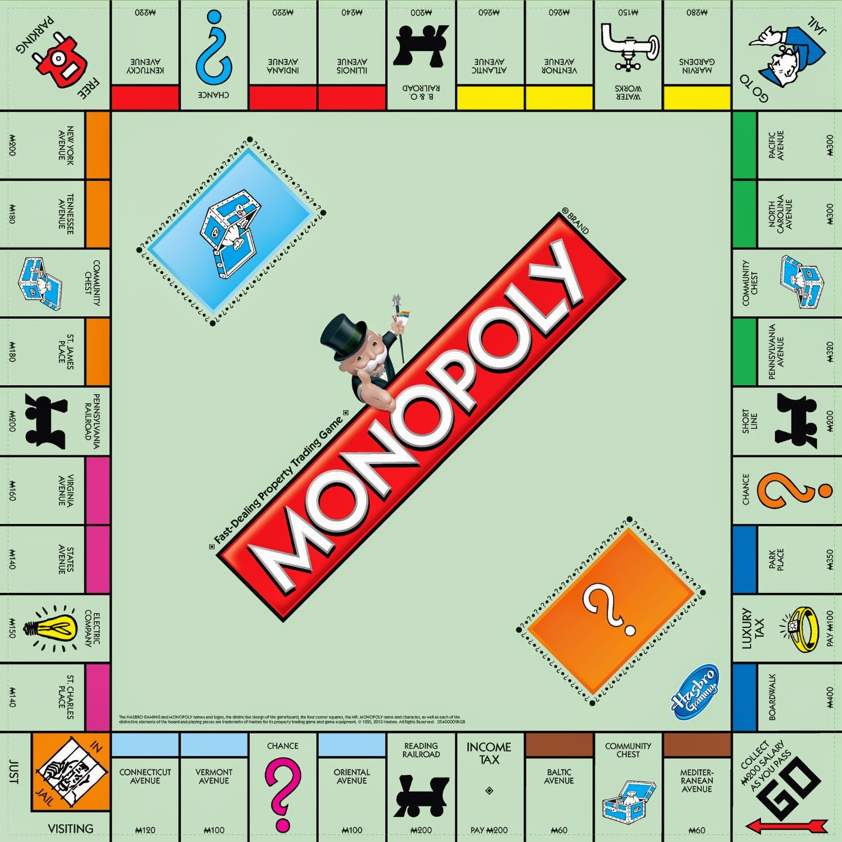

**Task 1 (Exam 1 – first folder):**

* Retrieve the title deeds in the file.
* Store the title deeds in an array list (use the structure created).
* Display all the title deeds calling the **displayTitleDeed()** repeatedly.

**Task 2 (Exam 2 – second folder and will be used also by Task 3):**

* Create a function that will initialize the game board with default values called **initGameBoard()**.
* The function will accept the Game Board instance.
* The owned by bank title deeds will retrieve all titles from the file “titledeed.cis”.
* Sets the board lot into the designated values:
  + Property lots owned by the bank will have zero (0) as value.
  + Index zero is the starting position marked as GO in the board which will be owned by the bank.
  + Community Chest will have the value -1.
  + Chance marked as question mark (?) will have the value -2.
  + Free parking will have the value -3.
  + Income tax will have the value -4.
  + Jail will have the value -5.
  + Electric company will have the value -6.
  + Water works will have the value -7.
  + The transportation will have the value -8, -9, -10, and -11 respectively starting from position 0.
  + Go to jail will have the value -12.
* Set the values for the cash dispenser.
  + Index 0 will be for $500
  + Index 1 will be for $100
  + Index 2 will be for $50
  + Index 3 will be for $20
  + Index 4 will be for $10
  + Index 5 will be for $5
  + Index 6 will be for $1
  + All of the them should have 30 bills each denomination.
* Set the total money based on the cash dispenser.
* The players array will contain the active players of the game initially empty.
* The player count will contain the number of active players.
* The house count is the number of houses available to be leased. This gets subtracted once a player will acquire a house. This gets added when the property owners sell the house.
* The hotel count is the number off hotels available to be leased. When the property owner wants to buy more house after buying 4 houses this will be converted to a hotel. The 4 houses will be retrieve and change into a hotel property.
* Chance and community chest cards are the cards that either brings good or bad luck drawn after the player lands on board lots mark with this. ***(just mark this as empty or no need to implement as it was not yet used for the current version)***
* The top is just the current position of the next card to be drawn. Set as 0.
* The dice is for the two dice values after roll by each of the player that will be used to move the players position in board. Consecutive 3 similar values would land the player automatically to the jail and will skip it’s turn.

**Task 3 (Exam 2 – second folder and same as Task 2):**

* Create a function that will add a player called **addPlayer()** and insert them at the rear of the players field in the Game Board instance.
* This will accept the Game board instance and the player id.
* The properties owned will be initially be empty.
* The player will initially receive 2pcs-$500, 2pcs-$100, 2pcs-$50, 6pcs-$20, 5pcs-$10, 5pcs-$5, and 5pcs-$1.
* Set the total money.
* The starting position as zero.
* Add 3 players to the current instance of the board by calling your **addPlayer()**. This should adjust necessary values needed.

**Task 4 (Exam 3 – third folder):**

* Create a function called **acquireProperty()**.
* The function will accept the Game Board, the id of the player, and the id of the title deed.
* Scenarios
  + The title deed is still owned by the bank.
    - The title deed will then be **transferred** into the player’s possession of title deeds. Take note that the player’s collection of deeds is stored in a **sorted manner** based on the id of the title deed.
    - The operation will only be successful also if the player has the sufficient funds to acquire the title deed.
    - The title acquisition price is based on the rent price.
    - Adjust necessary values in the Game Board including the counters and the money used.
  + The title deed is already owned by the current player but no house or still lesser than 4 houses.
    - Automatically adds one house in the property in possession of the player’s properties.
    - The player pays the house cost to the bank.
    - The bank gives the house.
    - Adjust necessary values in the Game Board including the counters and the money used.
    - The operation will not be successful if the player doesn’t have sufficient money to acquire for a house.
  + The title deed is already owned by the current player but has 4 houses.
    - Automatically the houses will be converted to a hotel.
    - The player pays the cost to the bank and give back the 4 houses.
    - The bank then gives a hotel.
    - Adjust necessary values in the Game Board including the counters and the money used.
    - The operation will not be successful if the player doesn’t have sufficient money to acquire for a hotel.
  + The title deed is already owned by another player.
    - Automatically you can acquire the title deed and its properties times 3 of the current value of the property based on the rent value depending on the lot, number of houses, or hotel present.
    - Adjust necessary values in the Game Board including the counters and the money used.
    - The operation will not be successful if the player doesn’t have sufficient money to acquire the title deed and its properties.
* You have the option to create smaller functions for different scenarios presented above.

**Task 5 (Exam 4 – fourth folder):**

* Create a function called **storeProperty()**.
* The function will store the title deeds owned by a specified player into file.
* The name of file should have the extension cis.
* The name of file should be “player” + the id of the player + “_titledeeds”.

**Title Deed Information:**

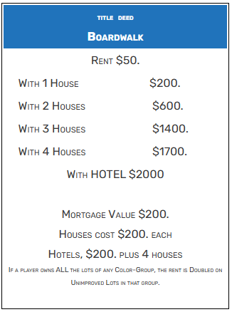The title deed contains the following:

* id
* name of the title deed
* the color of the title deed
* the amounts and cost stored in an array
  + index 0 for rent cost of title
  + index 1 for rent cost for other players with 1 house
  + index 2 for rent cost for other players with 2 houses
  + index 3 for rent cost for other players with 3 houses
  + index 4 for rent cost for other players with 4 houses
  + index 5 for rent cost for other players with a hotel
  + index 6 is the mortgage value to bank
  + index 7 is the acquisition cost for a house
  + index 8 is the acquisition cost for a hotel which is times 5 of the cost for a house in index 7

**LIBRARIES**

* stdbool.h
  + usage for the values true or false using the datatype **bool**
* string.h
* stdlib.h
* stdio.h